**MALIK ZOHAIB MUSTAFA**

**01-134192-039**

**BS(CS)-4B**

### Q1: Configure Routing Information routing protocol between three routers

**Tasks:**

**Introduction (devices Connectivity, IP Assigning)**

Giving no shutdown command to port 0/0 of router0

Assigning IP address to port 0/0 of router0: Assigning IP to serial port 2/0 of router0

Giving no shutdown command to port 0/0 of router1 Assigning IP address to port 0/0 of router1:

Assigning IP to serial port 2/0 of router1 and giving no shutdown command

Assigning IP to PC0, which will have a default gate (192.168.1.1) and IP 192.168.1.2, which is connected to router0

Similarly, same gateway for PC1 with IP 192.168.1.3 and PC2 with IP 192.168.1.4

Assigning IP to PC3, which will have a default gate (192.168.3.1) and IP 192.168.3.2, which is connected to router1

Similarly, same gateway for PC4 with IP 192.168.3.3 and PC5 with IP 192.168.3.4

Giving router rip command to router0 Giving router rip command to router1

## Packet Simulation

Packet simulation between PC2 and PC4 which belong to different networks.

## Connection Testing Between Different Networks

Testing the connection between PC0 and PC4 both belongs to different networks

So they are communicating

Testing the connection between PC5 and PC1 both belongs to different networks So, they are also communicating with each other.

## ANSWER:

**Introduction (devices Connectivity, IP Assigning:**

The Routing Information Protocol (RIP) is a relatively old, but still commonly used, interior gateway protocol (IGP) created for use in small, homogeneous networks. It is a classical distance-vector routing protocol. RIP is documented in RFC 1058.

RIP uses broadcast User Datagram Protocol (UDP) data packets to exchange routing information. The Cisco IOS software sends routing information updates every 30 seconds; this process is termed advertising. If a router does not receive an update from another router for 180 seconds or more, it marks the routes served by the non-updating router as being unusable. If there is still no update after 240 seconds, the router removes all routing table entries for the no updating router.

The metric that RIP uses to rate the value of different routes is hop count. The hop count is the number of routers that can be traversed in a route. A directly connected network has a metric of zero; an unreachable network has a metric of 16. This small range of metrics makes RIP an unsuitable routing protocol for large networks.

If the router has a default network path, RIP advertises a route that links the router to the pseudo network

* + - 1. The network 0.0.0.0 does not exist; RIP treats 0.0.0.0 as a network to implement the default routing feature. The Cisco IOS software will advertise the default network if a default was learned by RIP, or if the router has a gateway of last resort and RIP is configured with a default metric.

RIP sends updates to the interfaces in the specified networks. If an interface's network is not specified, it will not be advertised in any RIP update.

## Devices Connectivity:

The Routing Information Protocol (RIP) sends routing-update messages at regular intervals and when the network topology changes. When a device receives a RIP routing update that includes changes to an entry, the device updates its routing table to reflect the new route. The metric value for the path is increased by 1, and the sender is indicated as the next hop. RIP devices maintain only the best route (the route with the lowest metric value) to a destination. After updating its routing table, the device immediately begins transmitting RIP routing updates to inform other network devices of the change. These updates are sent independently of the regularly scheduled updates that RIP devices send.

## IP Assigning:

IP/RIP routers transmit and receive RIP updates to and from neighboring routers. These updates, which include a copy of a router's entire routing table are sent out every 30 seconds by default. The frequency of these updates can be modified.

The following command sequence enables routing and assigns IP addresses for ports 1/0/2 and 1/0/3.

**config interface 0/2 routing**

**ip address 192.150.2.1 255.255.255.0**

**exit interface 0/3 routing**

**ip address 192.150.3.1 255.255.255.0**

**exit exit**

# Implementation of routing information Protocol:

It requires only two steps to configure the RIP routing.

* + - * + Enable RIP routing protocol from global configuration mode.
        + Tell RIP routing protocol which networks you want to advertise.

Let’s configure it in Router0

### Router0:

Router0 (config) #router rip

Router0 (config-router) # network 10.0.0.0 Router0 (config-router) # network 192.168.1.252 Router0 (config-router) # network 192.168.1.248

#### ***Router rip*** command tell router to enable the RIP routing protocol.

***Network*** command allows us to specify the networks which we want to advertise. We only need to specify the networks which are directly connected with the router.

**Router1:**

Router1 (config) #router rip

Router1 (config-router) # network 192.168.1.244 Router1 (config-router) # network 192.168.1.248

### Router2:

Router2 (config) #router rip

Router2 (config-router) # network 20.0.0.0 Router2 (config-router) # network 192.168.1.252 Router2 (config-router) # network 192.168.1.244

#### Our network is ready to take the advantage of RIP routing. To verify the setup we will use ping command. ping command is used to test the connectivity between two devices.

We access the command prompt of **PC1** and use ping command to test the connectivity from **PC0**.

**Packet Simulation:**

* *Router0:* Router>en Router#conf t

Router(config)#hostname Router0 Router0(config)#int s0/3/0

Router0(config-if)#ip add 192.168.3.1 255.255.255.252 Router0(config-if)#no shut

Router0(config-if)#desc connection to Router1 Router0(config-if)#int f0/0

Router0(config-if)#ip add 192.168.0.1 255.255.255.0 Router0(config-if)#no shut

Router0(config-if)#desc connection to LAN Router0(config-if)#exit Router0(config)#router RIP Router0(config-router)#netw 192.168.0.0

Router0(config-router)#netw 192.168.3.0 Router0(config-router)#no auto Router0(config-router)#exit Router0(config)#exit

Router0#copy run start

* *Router1:* Router>en Router#conf t

#### Router(config)#hostname Router1 Router1(config)#int s0/3/0 Router1(config-if)#clock rate 64000

Router1(config-if)#ip add 192.168.3.2 255.255.255.252 Router1(config-if)#no shut

Router1(config-if)#desc connection to Router0 Router1(config-if)#int s0/2/0

Router1(config-if)#clock rate 64000

Router1(config-if)#ip add 192.168.4.1 255.255.255.252 Router1(config-if)#no shut

Router1(config-if)#desc connection to Router2 Router1(config-if)#int f0/0

Router1(config-if)#ip add 192.168.1.1 255.255.255.0 Router1(config-if)#no shut

Router1(config-if)#desc connection to LAN Router1(config-if)#exit Router1(config)#router RIP

Router1(config-router)#netw 192.168.1.0

Router1(config-router)#netw 192.168.3.0

Router1(config-router)#netw 192.168.4.0 Router1(config-router)#no auto Router1(config-router)#exit Router1(config)#exit

Router1#copy run start

* *Router2:* Router>en Router#conf t

#### Router(config)#hostname Router0 Router2(config)#int s0/3/0

Router2(config-if)#ip add 192.168.4.2 255.255.255.252 Router2(config-if)#no shut

Router2(config-if)#desc connection to Router1 Router2(config-if)#int f0/0

Router2(config-if)#ip add 192.168.2.1 255.255.255.0 Router2(config-if)#no shut

Router2(config-if)#desc connection to LAN Router2(config-if)#exit Router2(config)#router RIP

Router2(config-router)#netw 192.168.4.0

Router2(config-router)#netw 192.168.2.0 Router2(config-router)#no auto Router2(config-router)#exit Router2(config)#exit

Router2#copy run start

* *Verification:*

#### To verify the working of the lab, we need to confirm that we are learning all routes via RIP. To do this, we need to use **#show ip route** command.

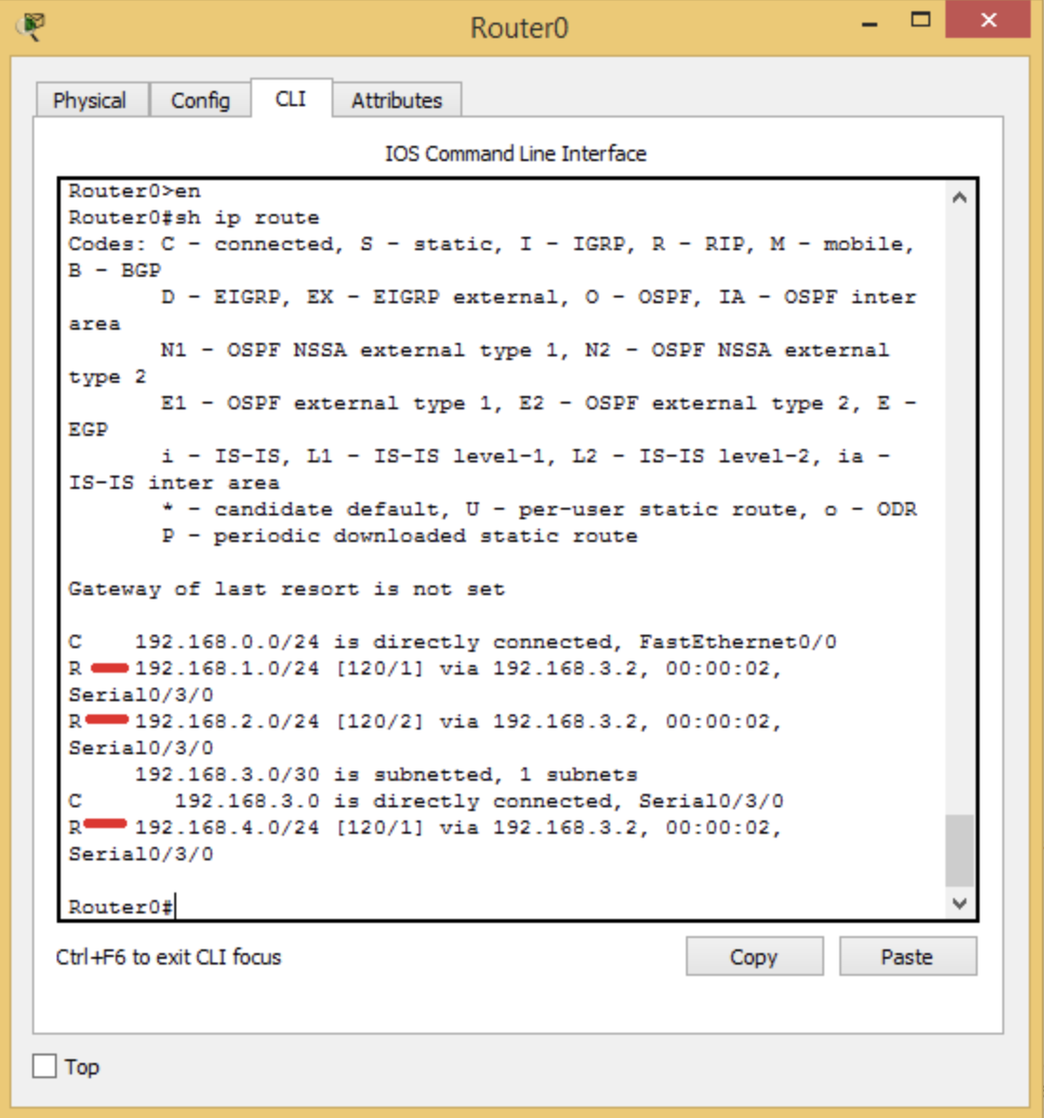

From Router0, we can see that networks 192.168.1.0/24, 192.168.2.0/24, and 192.168.4.0/24 are all being learned via RIP with default administrative distance of 120 and the hop count for network 192.168.2.0/24 recorded as 2. This is because network 192.168.2.0/24 is two routers away from Router0.

# Connection Testing Between Different Networks:

#### Configuring RIPv2 is a pretty straightforward process. Only three steps are required:

* Enabling RIP by using the *router rip* global configuration command
* Instructing the router to use RIPv2 by typing the *version 2* command
* Telling RIP which networks to advertise by using one or more *network* commands.

First, we assign the IP addresses on all the routers and then we can use following command to join those networks using RIP protocol:

**Router(config)#router rip**

**Router(config-router) #network10.x.x.x (Neighbor router network) Router(config-router) #network192.x.x.x (Neighbor router network)** If we want to use RIP version2 then:

**Router(config) #router rip Router(config) #version2**

**Router(config-router) #network10.x.x.x (Neighbors router network) Router(config-router) #network192.x.x.x (Neighbors router network) Router(config)#no auto-summary**

